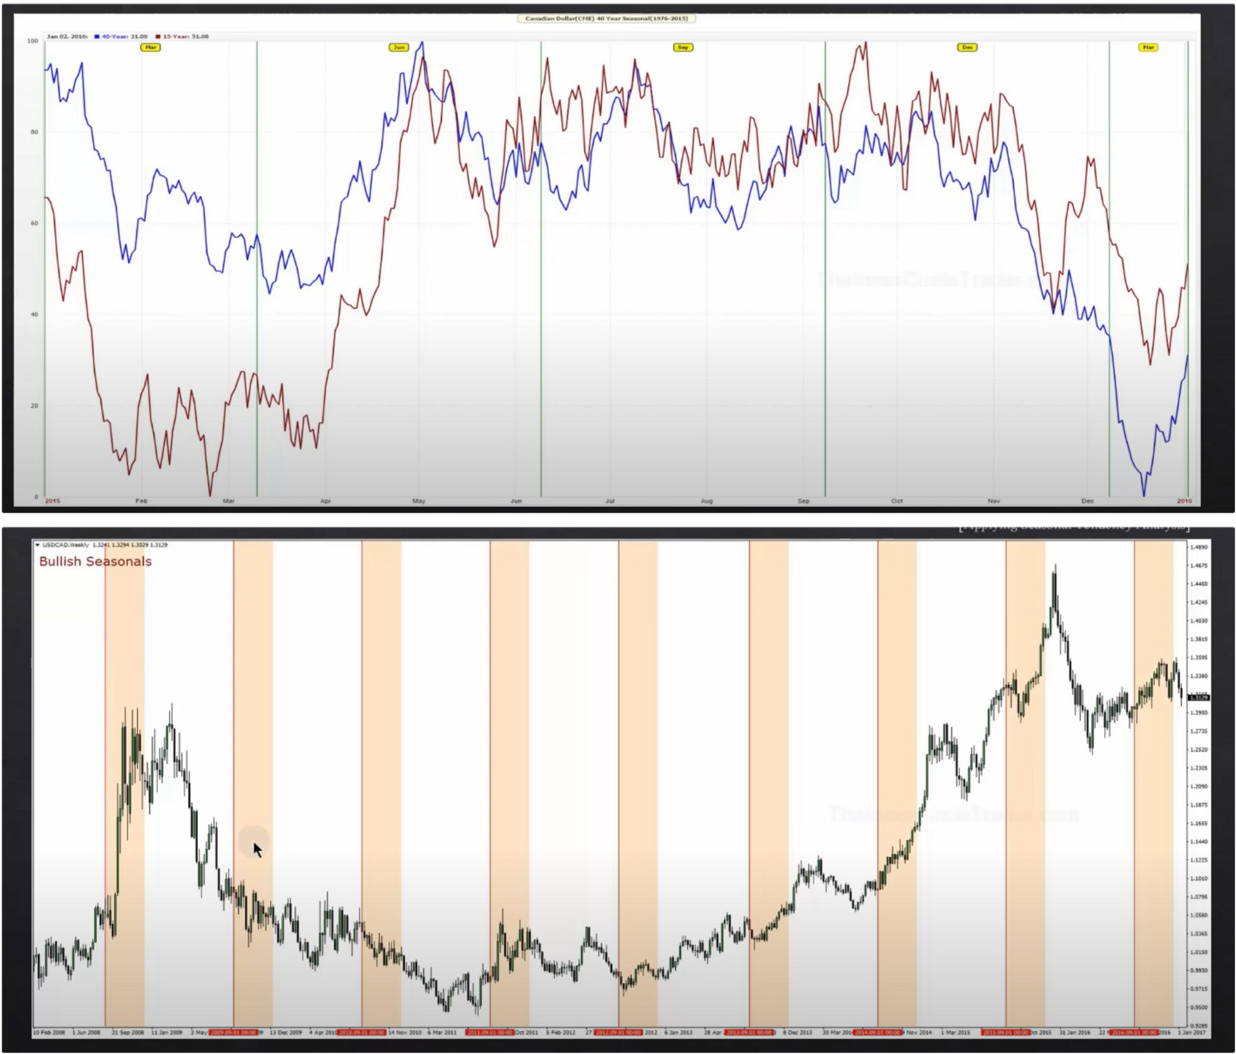**How To Use Bullish Seasonal Tendencies In HTF Analysis**

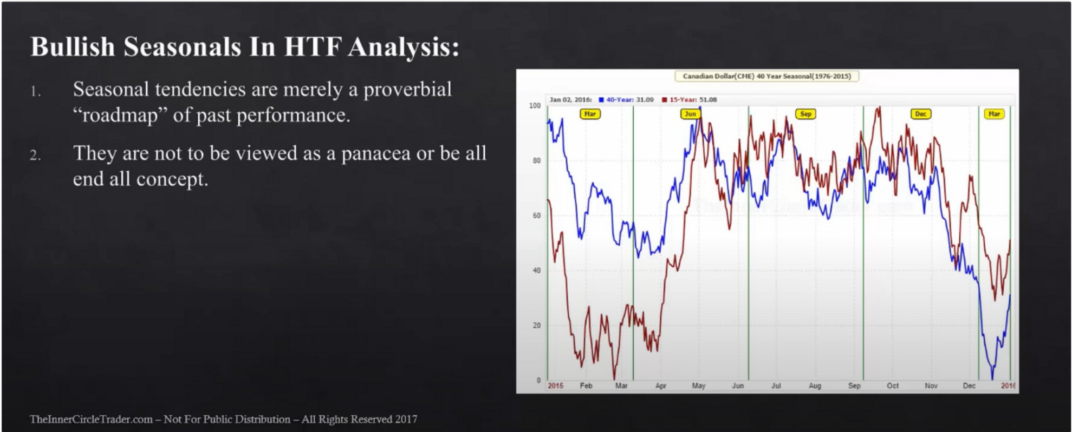

Seaonal tendency are just another confluence Canadian dollar seasonal tendency

When were clearly bearish on USDCAD technical then dont expect the seasonal bullish tendency to play out

Now we can couple this with quarterly shifts, couple the seasonal tendencies with quarterly shifts

Seasonal tendencies give us a roadmap, which quarter we want to be a buyer and which quarter to be a seller

**l -.mg B11ll1-.h Sl'ti\011.11 h-mlt•nnt·s In II** I I **\n.1h\1\**

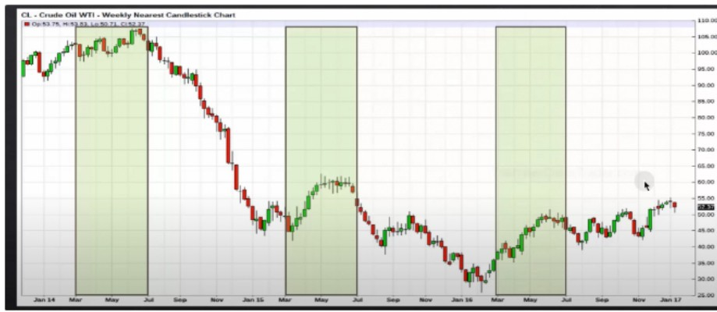

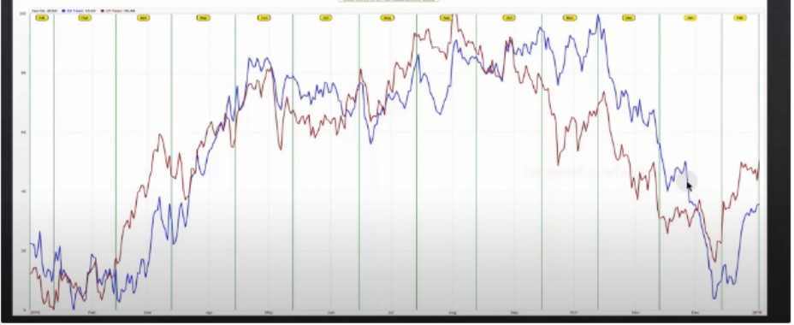

Crude oil seasonal tendency

Canadian dollar is closely related to crude oil because its the number 1 export Certain markets have really stong seasonal tendencies

Arjo I Twitter, lnstagram I Linktree

Linktree. Make your link do more.

, https://t.co/HhmmTN1fUI

JavaScript is not available.

**'I#** https://twitter.com/arjoio